Report:

Title: Charpy Impact Test

1. **Objective**
2. To study the impact resistance of metals using Impact testing machine of the Charpy type.
3. To determine the variation of impact strength of a material with change in temperature.
4. **Experimental Method(s):**
5. Noted down the dimensions of the specimen using the vernier calliper and find the working area of the specimen at the place of notch
6. With no specimen on the anvil, raise the pendulum to an initial reading and release it
7. Noted the reading of the pointer on the dial. The difference is the energy loss due to friction.
8. Now firstly me measured the temperature of the specimen using the multimeter and then placed the specimen in position of the anvil.
9. Raised the pendulum to the same initial height and released. The pendulum swings to the other side rupturing the specimen.
10. Noted the reading R3 on the dial.
11. Repeated the process at higher and lower temperatures of the specimen and examined the variation of the impact strength.
12. Tabulated the readings.
13. **Results and Calculations:**

* Dimensions of the Specimen = 60 mm x 10 mm x 10 mm
* Notch = 2 mm
* Area under Notch = 80 mm2
* Maximum Possible Energy Value = 402.85 J (Charpy test machine)
* Energy Loss Due to Friction = 1.4673 J
* Impact Strength (J/m2) = (Energy Absorbed/Area under Notch) = (Energy Absorbed/80 x 10-6 m2

|  |  |  |  |  |  |
| --- | --- | --- | --- | --- | --- |
| **Sr No.** | **Condition of Sample** | **Voltage (mV)** | **Temperature (˚C)** | **Impact Energy (J)** | **Impact Strength (J/m2)** |
| **1** | At room temperature(mildsteel) | **-** | 27 ⁰C | 90.506 J | 1131325 |
| **2** | Heated | 8.1 mV | 202.5 ⁰C | 99.924 J | 1249050 |
| **3** | Heated | 9.1 mV | 227.5 ⁰C | 107.24 J | 1340500 |
| **4** | Cooled | -4.9 mV | -122.5 ⁰C | 3.1315 J | 39143.75 |
| **5** | Cooled | -4.2 mV | -105 ⁰C | 6.0287 J | 75358.75 |
|  |  |  |  |  |  |

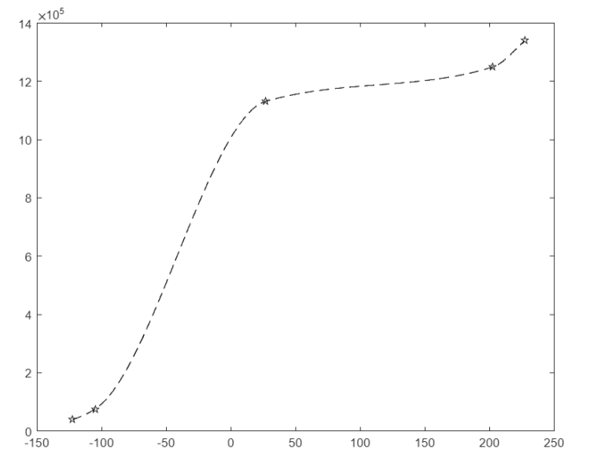

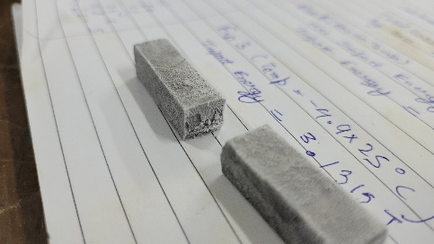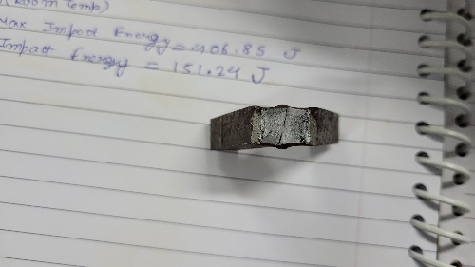

1. **Analysis/observations/discussion**
2. The strain fields in aluminium will be constant throughout the material because it is homogeneous and isotropic.
3. After rupture of the mildsteel specimen the fractured surface was smooth and plain at the lower temperature which shows the brittle nature of the specimen.
4. While at higher temperature, it was rough and irregular which shows the ductile nature of the mildsteel at high temperature.
5. At lower temperature the specimen shatters in two pieces which also verifies the brittle nature while at higher temperature it didn’t shattered in two pieces verifying the ductile nature.
6. Impact strength is low at low temperatures and high at higher temperatures; and increases rapidly in a short temperature range. This region is called the ductile-to brittle transition region. The metal is ductile above this region, and brittle below it
7. **Summary/conclusions.**
   1. We learned that the mildsteel becomes brittle at lower temperature while it becomes ductile at high temperature.
   2. We plotted the relationship between impact strength and temperature of mild steel, and observed the ductile-to-brittle transition region. We also observed the fracture surface for brittle and ductile fractures.
   3. Yes , we meet our objective of the experiment both quantitatively and qualitatively as the graphs was fairly consistent with the literature.
   4. The experimental dynamic impact strength of the mildsteel was 2.0214GPa which is fairly around the literature value that is 2 GPa.
   5. The impact energy at just higher temperature was unexpectedly found to be lower than that of room temperature. Possible sources of error could be manufacturing defects in the charpy specimen, incorrect calibration or incorrect unsymmetric placement of the specimen on the anvil.
   6. At lower temperatures, cracked surface has a shiny appearance (Brittle Nature)
   7. At higher temperature, cracked surface has fibrous/silky appearance with distortion at sides (Ductile Nature).
   8. Sources of error:
   9. There might be errors during the calibration of the impact testing machine.
   10. Errors while measuring the temperature of the specimens.
   11. Error due to incorrect adjustment of specimen on the anvil.